**1. Program Name:**

Generating Fibonacci Series.

**Program Description:**

In this python code, firstly a user input was taken which was an integer number. This integer number indicating the number of Fibonacci series. Firstly 0 and 1 was printed as well as they were assigned in two variables a, b respectively. After that a for loop was initialized from 0 to x-2 where x was the user input number. In the loop the summation of a and b was assigned to s and s was printed and then b and s was assigned into a and b variables respectively to get the Fibonacci series.

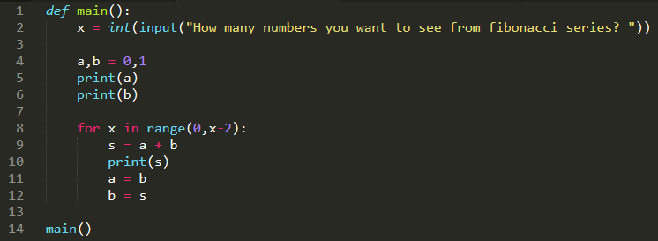**Code:**

**Output:**

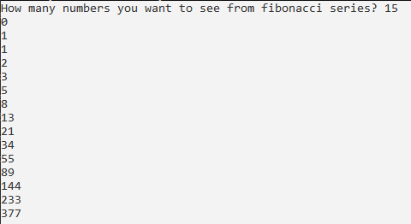

**2. Program Name:**

Generating Prime Numbers.

**Program Description:**

In this python code, firstly a function is_prime() was declared which takes an integer number as input parameter and checks if the number is 0 or 1 , if so then it returns false. After that, a for loop was initialized from 2 to that number and it checks if that numbers divisible by the numbers onwards 2, if so then it returns false otherwise true. Then the main function was declared and in that function, a variable n was declared to take the user input which indicates prime numbers till nth number. Then a for loop was initialized from 0 to n and in that loop is_prime() function was called for each values of x. If is_prime() returns true, then that number was printed.

**Code:**

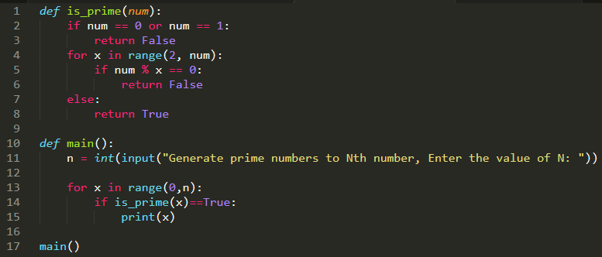 **Output:**

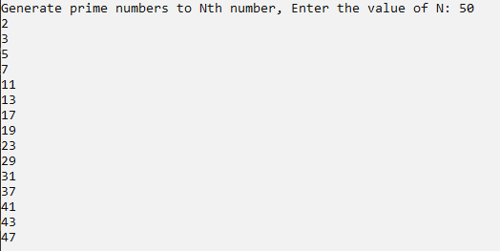

**3. Program Name:**

Printing Triangle using *

**Program Description:**

In this python code, in the main() function, a variable n was declared to get the user input which is an integer. The value of n indicates the number of row of the triangle. And k was declared and 2*n – 2 was assigned to it. The value of k is the number of spaces. Then a for loop was initialized from 0 to n which is outer loop for the rows. And inside that another for loop was initialized from 0 to k for printing the spaces. After each of the inner loop ends the value of k was decremented by 1. And then another loop was initialized from 0 to i+1 to finally print the *. After that print(“\r”) was used for ending line after each row.

**Code**:

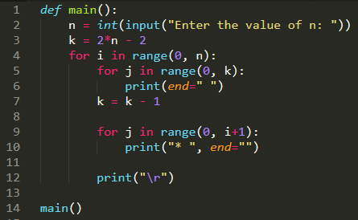

**Output:**